*Updated on October 25, 2024*

# **Welcome to the Analytics Tab!**

Whether you are looking to manage your organization’s metrics or find actionable insights, The **‘Analytics’** tab in your **CO Portal** lets you customize how you organize and interact with your metrics.

The **Analytics Tab User Guide** helps you learn to use the **‘Analytics’** tab better and faster. You will find details on features and other things that will help you use the **‘Analytics’** tab in the most efficient way possible.

***Please report any questions or issues with the Analytics tab to the AWS re/Start Customer Support Form*** [***https://support.aws.amazon.com/#/contacts/aws-restart***](https://support.aws.amazon.com/#/contacts/aws-restart)

Contents

Welcome to the Analytics Tab! 1

Instructions 2

Finding the **‘Analytics’** Tab 2

Using the **‘Delivery Metrics’ and ‘Placement Metrics’ and ‘Certification Exam Metrics’** 3

Filtering 3

Sorting 4

Updating Metrics 5

Appendix 6

How are the metrics in the Metrics Dashboard calculated? 6

Where do the metrics come from? 6

# **Instructions**

## Finding the **‘Analytics’** Tab

Log in to **CO Portal** using your username (usually this is email@email.com.awsrestart) and password.

Select the **‘Analytics’** tab.

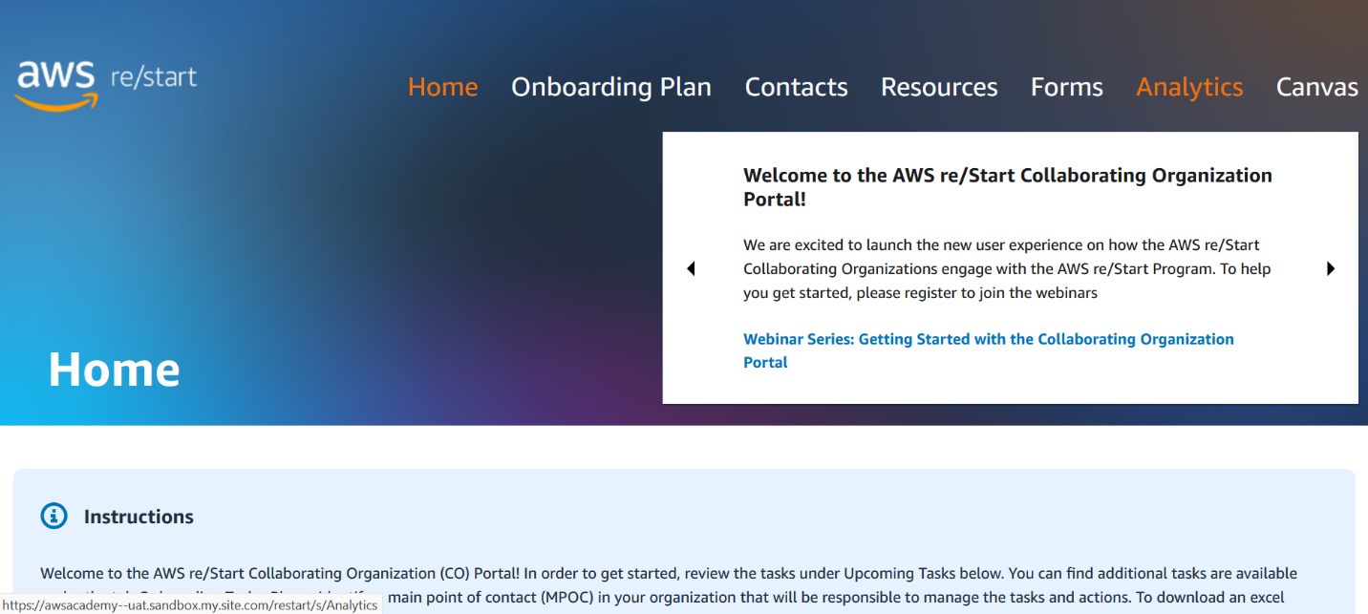

Select **‘Delivery Metrics’** to view delivery metrics.

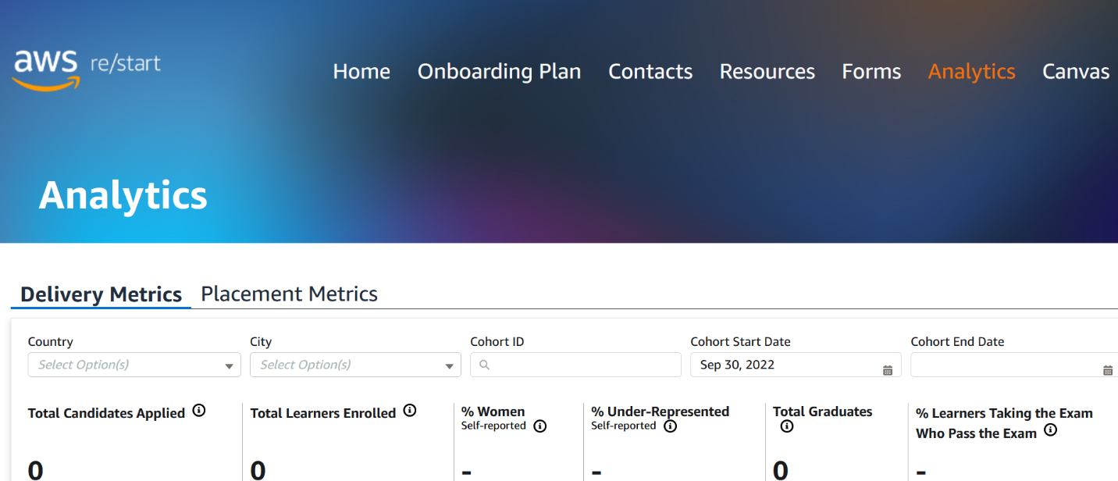

Select **‘Placement Metrics’** to view placement metrics.

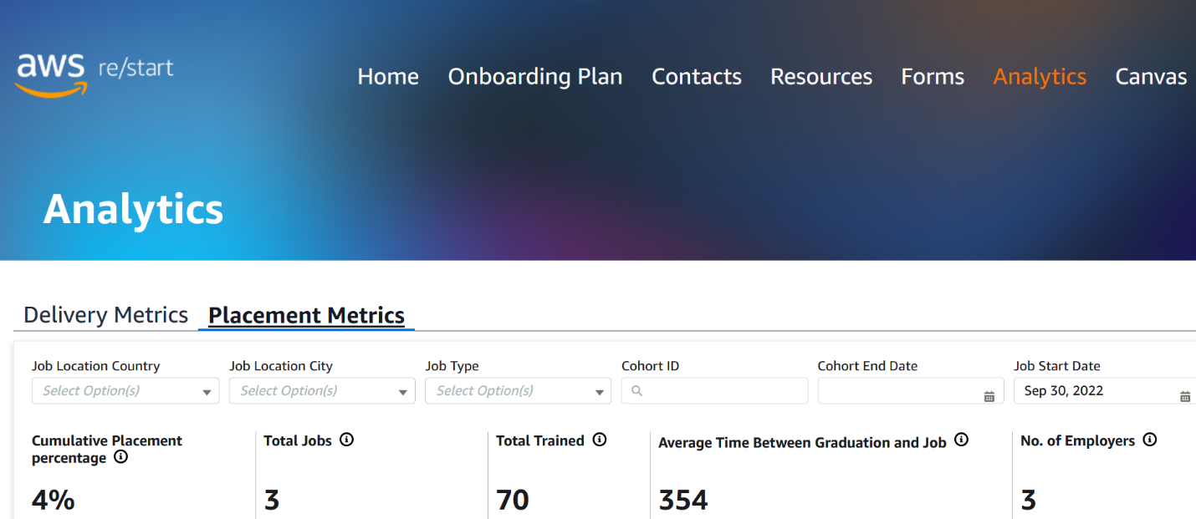

## Using the **‘Delivery Metrics’ and ‘Placement Metrics’ and ‘Certification Exam Metrics’**

### Filtering

Filtering helps you view the metrics you need. In the **‘Analytics’** tab, you can filter by many attributes and combine filters to find your metrics more accurately. When filters are applied, the active filters are always displayed.

Filter by selecting the attributes desired.

***Delivery Metrics*** *can be filtered by ‘Country’, ‘City’, ‘Cohort ID’, ‘Cohort Start Date’, ‘Cohort End Date’*

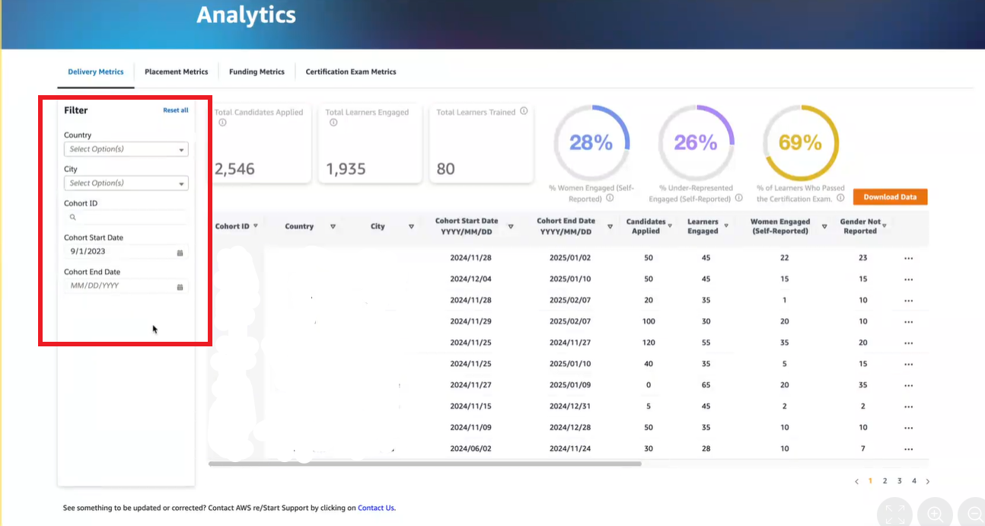

Default is set to last day of prior month. Please adjust as needed.

***Placement Metrics*** *can be filtered by ‘Cohort ID’, ‘Cohort End Date’, ‘Placement Country’, ‘Placement City’, ‘Placement Type’, ‘Placement Start Date’, ‘Placement Reported Date’*

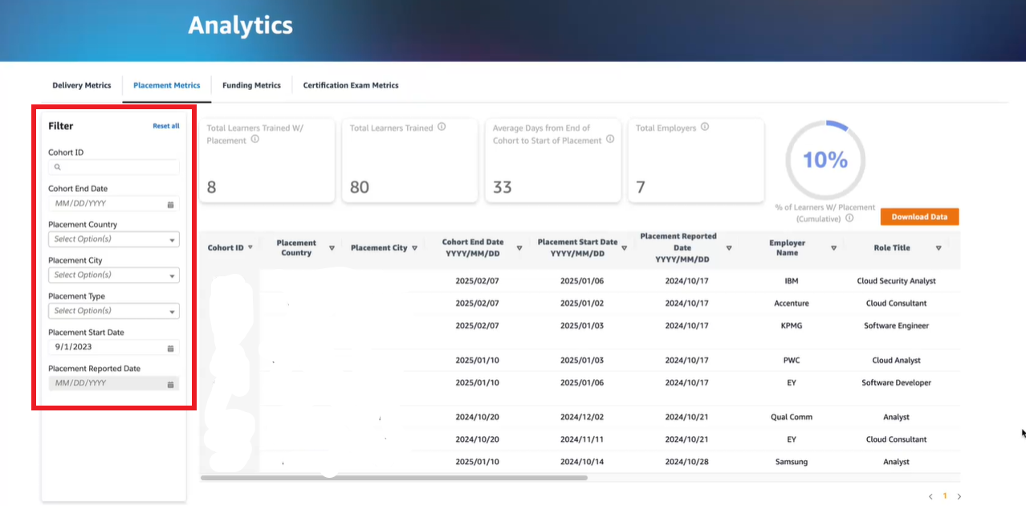

***Certification Exam Metrics*** *can be filtered by ‘Country’, ‘City’, ‘Cohort ID’, ‘Cohort Start Date’, ‘Cohort End Date’*

### 

### Sorting

Sorting helps you order your metrics so that you may view them in the order you desire. In the **‘Analytics’** tab, you can sort metrics by many attributes. When sorting is applied, the shaded arrow displays the attribute by which tasks are sorted.

*NOTE: The* ***‘Analytics’*** *tab only supports one level of sorting. In sorting tasks by a different attribute, it removes the initial sorting.*

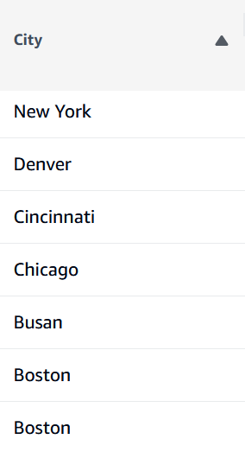

Z to A applied to ‘City’ attribute

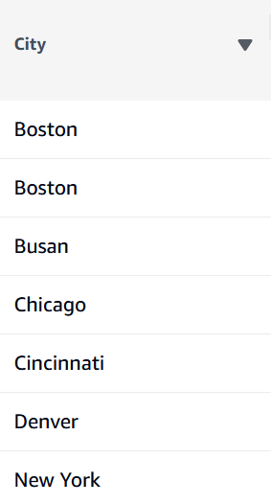

A to Z applied to ‘City’ attribute

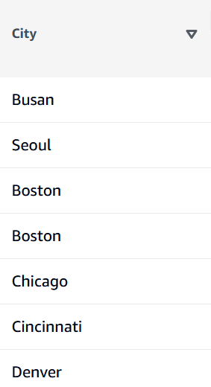

No Sorting applied to ‘City’ attribute

### Updating Metrics

You may update metrics in the **‘Delivery Metrics’** and **‘Certification Exam Metrics’** tabs. All metrics in these tabs that are submitted by the collaborating organization via the AWS re/Start Collaborating Organization Portal are editable. ‘Learners Engaged’ and ‘Learners Trained’ are not editable, as these metrics come directly from Canvas.

**‘MPOC’, ‘Course Coordinator’,** and **‘Metrics Lead’** roles in the collaborating organization have editing permissions. In order to make an update to metrics, hover on the three dots to the right of the row you wish to update.

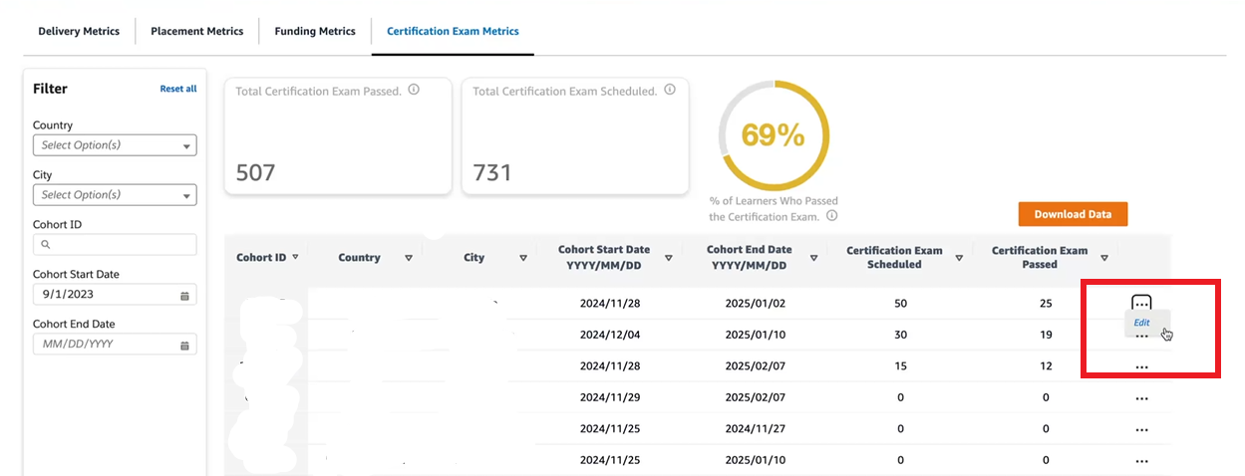

You will now see a pop-up which allows you to edit the metrics for the specific cohort selected.

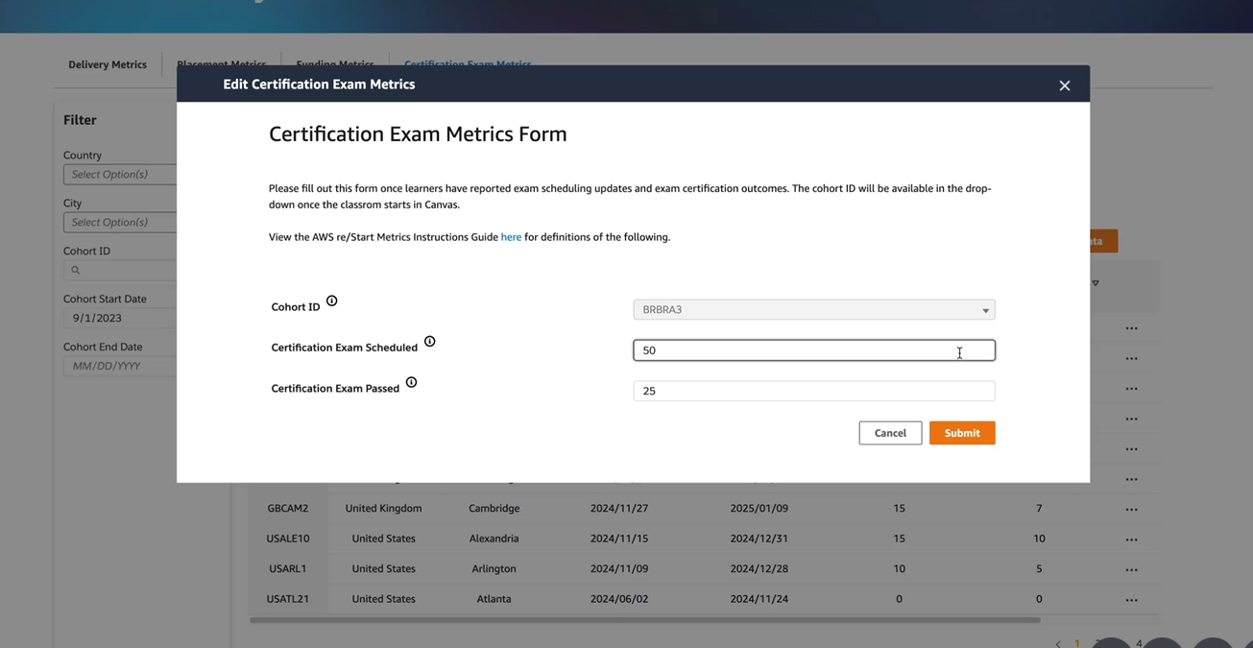

Select ‘Submit’ to complete updating metrics.

# **Appendix**

## How are the metrics in the Metrics Dashboard calculated?

***Delivery Metrics Dashboard***

|  |  |
| --- | --- |
| Metrics | This can be seen by selecting the ⓘ next to the Metrics |
| Total Candidates Applied | The sum of candidates applied is shown in this filtered result. |
| Total Learners Engaged | The sum of learners Engaged is shown in this filtered result. |
| % Women Engaged  (Self-Reported) | The cumulative percentage of learners Engaged who self-reported as women is shown in this filtered result (where permissibly legal to report – this is an optional field) |
| % Under-Represented Engaged  (Self-Reported) | The cumulative percentage of learners Engaged who self-reported as being from an under-represented group is shown in this filtered result (where permissibly legal to report – this is an optional field). |
| Total Learners Trained | The sum of graduates is shown in this filtered result. |
| % Graduates Passing the Exam | The cumulative percentage of graduates who passed the AWS certification exam is shown in this filtered result. |

***Placement Metrics Dashboard***

|  |  |
| --- | --- |
| Metrics | This can be seen by selecting the ⓘ next to the Metrics |
| % Graduates Placed | The cumulative percentage of graduates who are placed is shown in this filtered result |
| Total Graduates Placed | The sum of graduates who are placed is shown in this filtered result |
| Total Learners Trained | The sum of graduates is shown in this filtered result |
| Average Days from End of Cohort to Start of Placement | The average number of days from cohort end date to placement start date is shown in this filtered result |
| Total Employers | The sum of employers that hired re/Start learners is shown in this filtered result |

*NOTE: Graduates = Trained and Engaged = Engaged.*

## Where do the metrics come from?

***Delivery Metrics Dashboard***

|  |  |
| --- | --- |
| Metrics | Where does this come from? |
| Cohort ID | Submission of **‘Create Course’** in Canvas: Cohort ID |
| Country | Submission of **‘Create Course’** Canvas: Country of Delivery |
| City | Submission of **‘Create Course’** Canvas |
| Cohort Start Date  YYYY/MM/DD | Submission of **‘Create Course’** Canvas: Start Date |
| Cohort End Date  YYYY/MM/DD | Submission of **‘Create Course’** Canvas: End Date |
| Candidates Applied | **Delivery Metrics Intake Survey:** Number of candidates applied |
| Learners Engaged | Students accepted invite to Canvas |
| Women Engaged  (Self-Reported) | **Delivery Metrics Intake Survey:** Total number of women, self-reported (where permissibly legal to report – this is an optional field) |
| Gender Not Reported | **Delivery Metrics Intake Survey:** Total number of learners who did not report gender |
| Under-Represented Engaged  (Self-Reported) | **Delivery Metrics Intake Survey:** Total number of self-learners of under-represented minority, self-reported (where permissibly legal to report – this is an optional field) |
| Under-Represented Status Not Reported | **Delivery Metrics Intake Survey:** Total number of learners who did not report ethnicity |
| Learners Trained | Learners marked ‘Checkmark with solid fill’ for ‘Trained’ column in Canvas **Gradebook** based on re/Start program graduation criteria |
| Certification Exam Scheduled | **Certification Exam Metrics Form:** Total number of learners who reported they scheduled the exam |
| Certification Exam Passed | **Certification Exam Metrics Form:** Total number of learners who reported that they passed the exam |

***Placement Metrics Dashboard***

|  |  |
| --- | --- |
| Metrics | Where does this come from? |
| Cohort ID | **Placement Form:** Cohort ID |
| Placement Country | **Placement Form:** Job Location Country |
| Placement City | **Placement Form:** Job Location City |
| Cohort End Date  YYYY/MM/DD | **Placement Form:** Classroom End Date |
| Placement Start Date | **Placement Form:** Job Start Date |
| Employer Name | **Placement Form:** Employer Name |
| Role Title | **Placement Form:** Job Title |
| Role Type | **Placement Form:** Role Type Picklist |
| Placement Type | **Placement Form:** Job Type Picklist |
| Placement Connection Source | **Placement Form:** Job Connection Source Picklist |
| Placement Wage Rate | **Placement Form:** Job Wage Rate |
| Placement Wage Currency | **Placement Form:** Job Wage Currency Picklist |
| Placement Wage Period | **Placement Form:** Job Wage Period Picklist |
| Unique Identifier | **Salesforce Interal ID** for submission of Placement Form |